Clearasil Stubborn Acne Control 1 Minute Face Mask


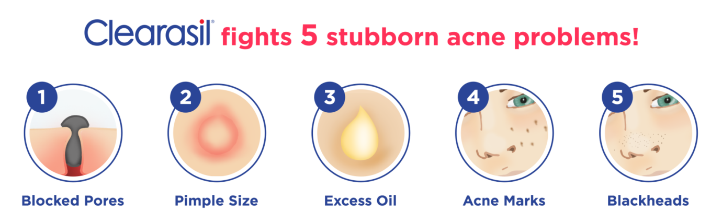

How to use - Mask
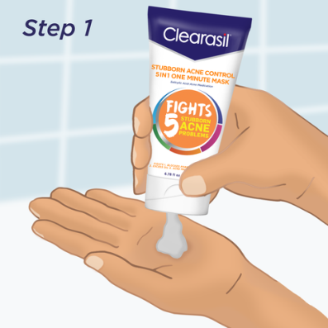  Wet face and dispense product into your hands | 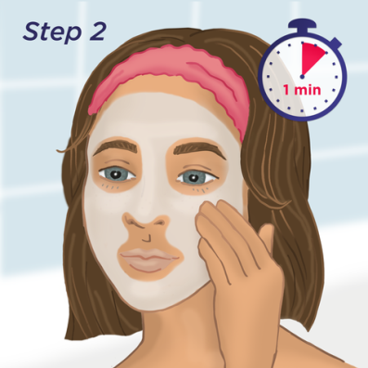  Apply onto damp skin and leave on for one minute | 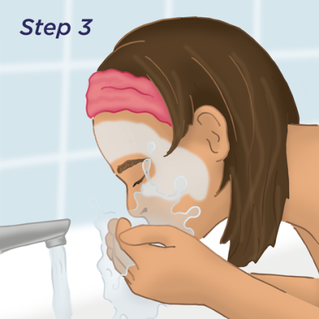  Rinse thoroughly with warm water and gently pat your skin dry  Frequency - Use 1-3X per week for a deeper treatment
