Product  Condensate Pumps  CP Series Condensate Pumps  Application  Condensate removal for HVAC/R equipment  Purpose  This product Is designed to automatically evacuate condensate or water discharge from HVACR equipment up to 22' vertically once the condensate in the reservoir reaches a specified level.  Advantages  AsurityTM CP-22 series pumps beat the industry standard of 20’ lift height by 2 feet and come with innovative features such as: vibration dampening feet and motor mounts, metal mounting tabs, four inlet holes (and 3 poly covers for the unused), LED indicators, float switch and duckbill-style check valve, and detailed installation instructions. Two terminals are provided allowing the installer flexibility to connect air-handler shut-down, an important safety consideration. CP-22 is available with 20’ of 3/8” tubing as well.  Utilizing the same great features but in a low-height (4-3/8”) design, the CP-22LP is great for tight spaces.  Maximum Condensate Temperatures  - Continuous duty 140°F  - Maximum inlet temperature 160°F  - Not suitable for contact with steam or gases that exceed 160°F  Rated Voltage  120VAC / 230VAC / 60hHz  Rated Current Draw  - 1.9 Amps (120VAC)  - 1.0 Amps (230VAC)  Input Type  - USA 3-prong molded plug (120VAC)  - NEMA 6-15 (230VAC)  Maximum Lift Height  - CP-22 series: 22’  (Every AsurityTM condensate pump is computer tested to ensure excellent performance at all pumping levels.)  Included Accessories  - Instruction Booklet  - Metal Hang Tabs (plastic on CP-16)  - 4’ Remote Shutoff Leads w/insulated terminals  - Polyethelene inlet covers (3)  Wiring Color References  - 120V  - Black – Live/Hot  - White – Neutral  - Green – Ground  - (All installations must conform to local building codes)  - 230V  - Brown – Live/Hot  - Blue – Live/Hot  - Green/Yellow – Ground  - (All installations must conform to local building codes) | 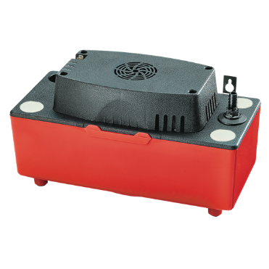  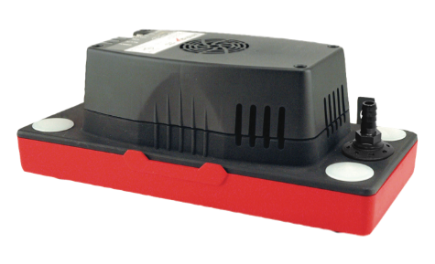  Flow Rate @ Zero Head  - CP-22: 1.6 gallons per minute  Dimensions  - CP-22: 11.8” x 5.9” x 6.7” (4.9” low profile)  - CP-22: 5 lbs. (4.7 lbs. low profile)  Inlet Height from Base  - CP-22: 4.4” (1.75” low profile)  Tank Capacity  - CP-22: 1/2 gallon  - CP-22LP: 3/8 gallon
SKU Specific Package Metrics
CATALOG NO. | DESCRIPTION | LIFT | UPC | ORDER MULTIPLE
CP-22 | 120V | 22’ | 095247091263 | 6
CP-22T | 120V w/ tubing | 22’ | 095247091287 | 6
CP-22-230 | 230V | 22’ | 095247092994 | 6
CP-22-230T | 230V w/ tubing | 22’ | 095247094578 | 6
CP-22LP | 120V low profile | 22’ | 095247094301 | 6
CP-22LP-230 | 230V low profile | 22’ | 095247131280 | 6

CP-22 Pump Performance Curve
