EC289 Assembling Instruction | (Pic for reference only)
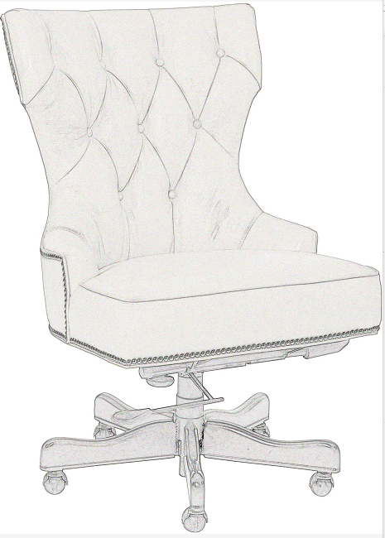  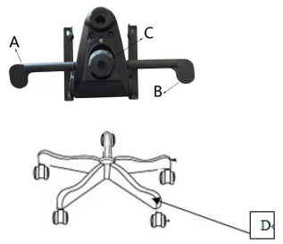 | Carefully unpack all parts and identify them with parts list and assemble the chair following the Assembly Instructions.  Put the chair onto a flat floor then you can sit onto and adjust the reclining and the seat height

Please sit down onto the chair and use the left handle (A) to adjust the reclining of the chair, and use the right handle (B) to adjust the height of it.

- Pull the left handle (A) out and the chair is active to recline. Get a desired tilt and release the left handle to lock it. You can lock at several different tilt angles by reclining your body.

- Turn the right handle (B) upward to activate the cylinder for adjusting the height of the chair. Raise your body up, the seat will be lifted up to a desired height by the cylinder. To get a lower height, please sit down with the right handle (B) turning upward. Release the right handle (B) to lock the cylinder when you achieve a desired seat height.

- Turn the knob (C) clockwise to lessen the tension and counter clockwise to tighten the tension

 | Parts As Shown
 | A. Left handle--for reclining
 | B. Right handle—for adjusting seat height
 | C. Tilt tension knob
 | D. Base set

EC289 Assembling Instruction | (Pic for reference only)
G  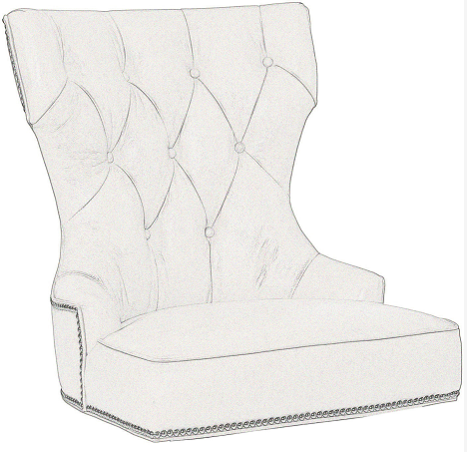  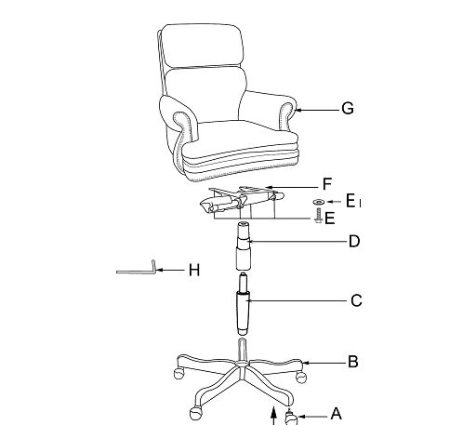  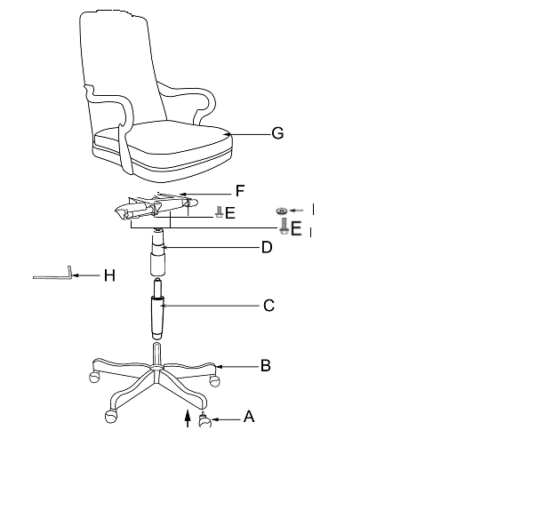  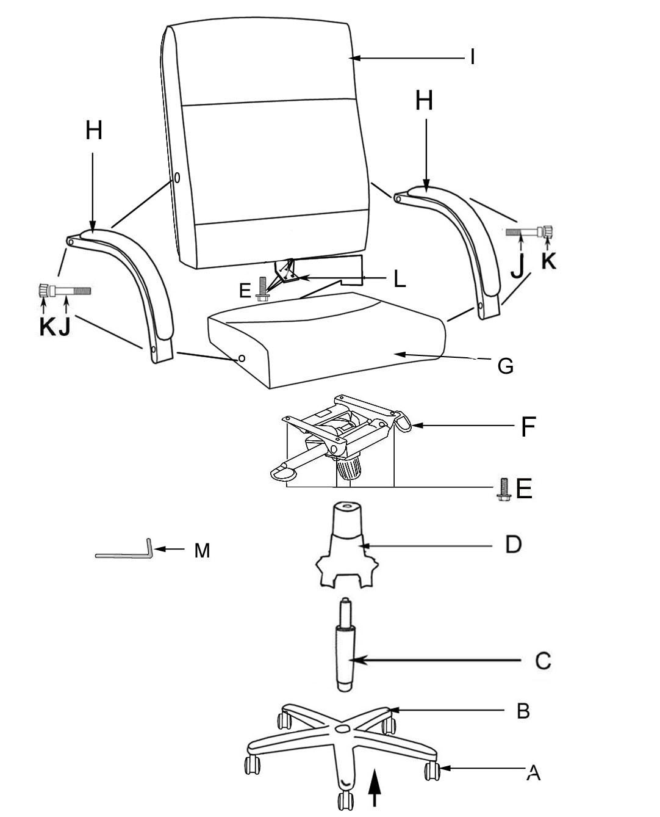 | Carefully unpack all parts and identify them with parts list before attempting to assemble the chair.  IMPORTANT: DO NOT TIGHTEN BOLTS AND SCREWS FULLY UNTIL YOU HAVE COMPLETED THE FINAL ASSEMBLY.

Carefully remove the 5 STAR BASE (B) from the carton. The base is located behind the fiberboard that is behind the chair UNIT SEATING(G).

Put 5 CASTERS (A) into the holes of 5 STAR BASE (B).
3. Insert GAS LIFT (C) to the center hole top of 5 STAR BASE (B), and put the BELLOWS (D) onto the GAS LIFT(C).
4. Attach SEAT PLATE (F) to the Unit Seating (G) by using 4 SCREWS (E) with 4 FLAT WASHERS (E1).
- Insert the pre-assembled seat unit onto the gas lift to finish the final assembly.
- Be sure that all the screws are fully tightened before using.
 | Parts List
 | A. CASTERS | 5
 | B. 5 STAR BASE | 1
 | C. GAS LIFT | 1
 | D. BELLOWS | 1
 | - SCREWS (5/16”x1-1/4”)  E1. FLAT WASHERS | 4  4
 | F. SEAT PLATE | 1
 | G. UNIT SEATING  H. ALLEN KEY | 1  1

