A+ Content

Title- VEET Botanic In Shower Cream
UPC- 00062200908494

VEET Botanic Cream

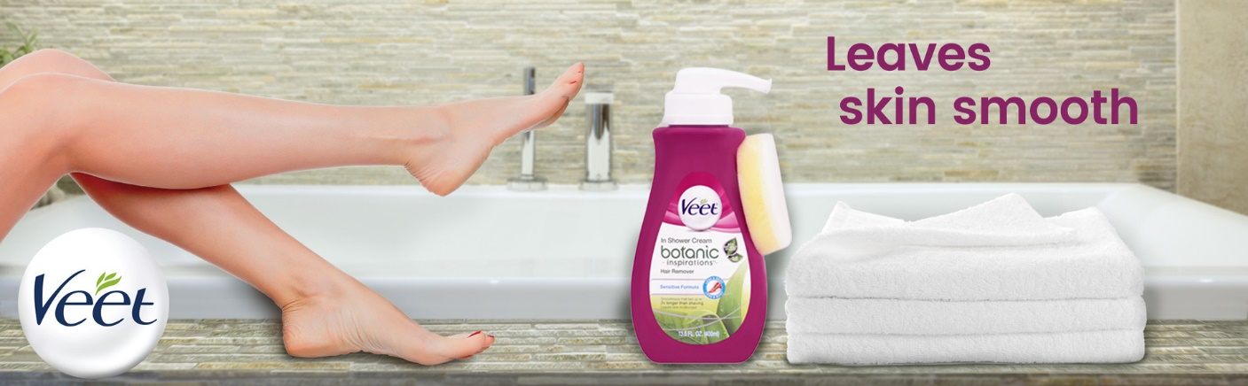
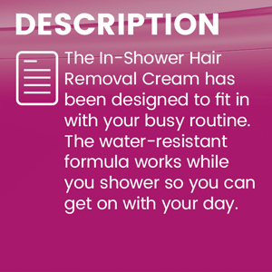 | 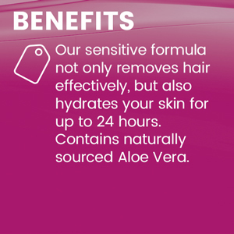 | 

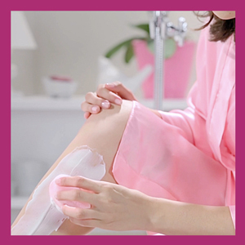  Before Use  Before showering, remove plug from the pump and turn counter-clockwise to unlock. Apply the cream evenly onto dry skin using the soft, coloured side of the dry sponge. Make sure the hair you want to remove is completely covered but do not rub in. Wash any cream off your hands. Once applied, wait at least 2 minutes before stepping into the shower. | 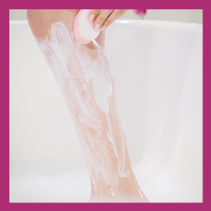  During Use  During your normal shower routine leave the cream on for 3 minutes by timing carefully. Don't worry if some cream gradually washes away when in contact with running water. Gently use the white side of the sponge to test a small area. If hair comes away easily, remove the rest of the remaining traces of cream with the white side of the sponge by massaging in circular motion. If needed, leave the cream for a bit longer Without Exceeding 10 Minutes of total application time. The soft, colored side of the sponge can be used for sensitive areas.. | 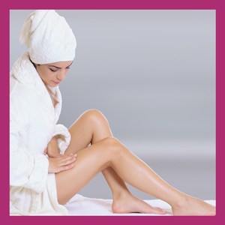  After Use  Rinse your skin thoroughly under the shower after use. Replace the plug after each use. Rinse the sponge and dry it. Store in an upright position.

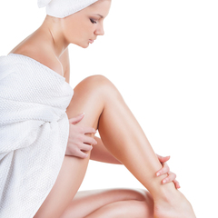 | How Do Creams Work?  The creams are chemical depilatories that use an active ingredient to dissolve the hair shaft. The mechanical action of removing the cream using the spatula or sponge helps pull away the dissolved hair from the surface of the skin.

Are Creams Suitable For Everyone?  Creams can be used by everyone, including pregnant women, as long you follow the precautions and directions for use. It is advisable for teenagers under 16 to be supervised by an adult when using any depilatory method. | 

 | Why Should The Product Be Tested Before Each Use?  The skin is a complex organ, and sensitive to changes in hormone levels. Since our skin is constantly changing, it is necessary to test each time to avoid any adverse reaction to the ingredients of the products.

Creams Vs. Waxing  Creams work so well because they go below the surface to dissolve the proteins that make up hair, so you're left feeling smoother for up to twice as long as shaving. For the longest lasting smoothness though, try waxing. Because waxing removes hair from the root, you're left with a silky smooth feeling that can last up to four weeks. When the hair eventually grows back, it's often sparser and softer, too. Waxing is easy to use and far more comfortable than you might imagine. | 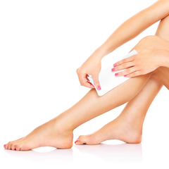

VEET Product Comparison
This product comparison table is displayed in preview mode, and shows all products. When displayed on a retailer site, only products in the retailer's product catalog are shown.

