P/N: VSC58-20M

5.8 mm cam with 20 m fiberglass-reinforced probe—QVGA via macro short focus
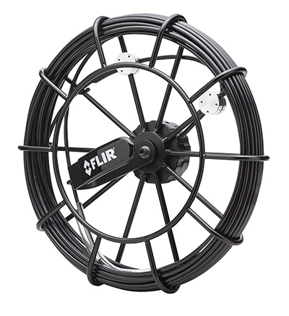
High-res image, RGB color space, 1000 px wide
Part No. | VSC58-20M
General information
Short description | 5.8 mm cam with 20 m fiberglass-reinforced probe—QVGA via macro short focus
Compatible main unit | VS70
Integrated handset | No
Wireless capabilities | N/A
Compatible wireless handset | With optional VST
Compatible detachable cameras | N/A
Warranty | https://www.flir.com/testwarranty

Camera specifications
Articulation | No
Diameter | 5.8 mm
Front camera focal length | 20–60 mm
Front camera field of view | 56°
Front camera resolution | QVGA (320 × 240) pixels
Probe length | 20 m
Video format | NTSC
Brightness control | Manual with variable options
Lamp type | LED
Power system
Power requirements | N/A

Environmental data
Operating temperature | –10 to 50°C (14–122°F)
Operating humidity | 80% maximum
Storage temperature | –40 to 80°C (–40 to 176°F)
Physical data
Weight | See shipping information
Dimensions (H × W × L) | See shipping information
Material | PC-ABS, rubber hand grip, nylon strap
Color | Gray, black

Shipping information
Packaging type | Brown shipping box
Packaging contents | Brown shipping box, hardcase, camera, camera attachments: mirror, anti-snag tip, magnet
Packaging weight | 4 kg
Packaging dimensions (H × W × L) | 45 cm × 37 cm × 17 cm
Carton weight | 9 kg
Carton dimensions (H × W × L) | 39 cm × 36 cm × 47 cm
Carton quantity | 2
EAN-13 | 0793950406007
UPC-12 | 793950406007
Country of origin | TW
Tariff code | 9013909000
Technical support
Website | http://support.flir.com

