P/N: 19252-100

FLIR IRW-4C: 4in Round Infrared Inspection Window (Aluminum)
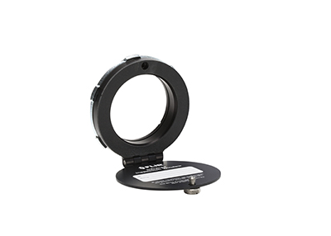
High-res image, RGB color space, 1000 px wide
General description
This device is a viewport which consist of a crystal "glass" window, mounted in an aluminum frame. The glass is specially formulated to allow transmission of infrared light to allow use of infrared thermal sensing equipment without opening the enclosure. This device is intended for installation in doors or walls of electrical enclosures without compromising the integrity of the enclosure.
Power system
Voltage | Any range

Environmental data
Environment | Indoor/outdoor type 4/12
Operating temperature range | Maximum: 260°C (500°F)
Storage temperature range | Optics, maximum: 1357°C (2474°F)
Physical data
Size (L × W × H) | 29.3 × 127 × 137 mm (1.15 × 5.01 × 5.37 in.)
Viewing aperture diameter | 89 mm (3.50 in.)
Material | Optics: CaF2 (Calcium Fluoride Crystal)  Body: Anodized aluminum  Hardware: steel
Comments to physical data | Required hole diameter, nominal: 114.3 mm (4.5 in.)  Greenlee Punch: 742BB  Maximum pullout strength: 1678 kg (3700 lb.)

Lens
Waveband | Broadband IR: short-, mid-, and longwave
Visible light spectrum | Yes
Certifications
Certification | UL, IP67, NEMA Type 4/12, CSA

Shipping information
Packaging, type | Cardboard box
List of contents | - IR window  - Case  - Mounting instruction  - Additional safety screw
Packaging, weight | 0.46 kg (1.01 lb.)
Packaging, size | 165 × 175 × 40 mm (6.50 × 6.89 × 1.58 in.)
EAN-13 | 4743254000742
UPC-12 | 845188002831
Country of origin | Estonia

