CAT IV Silicone Test Leads (TA80)
Go to Product Support
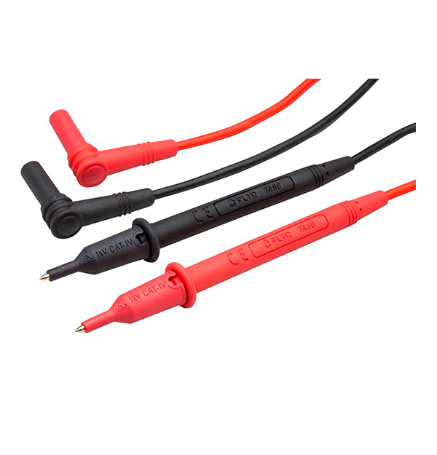
1000 V, 10 A test probes. UL certified to CAT IV–1000 V rating. Gold-plated tips for professional precision. Double-extruded multi-color silicone leads with wear indication. High-strength stress relief integrated into the probe. 41’ lead length with a total length of 46’ including the probe. Removable probe protection caps for 4mm tips.

